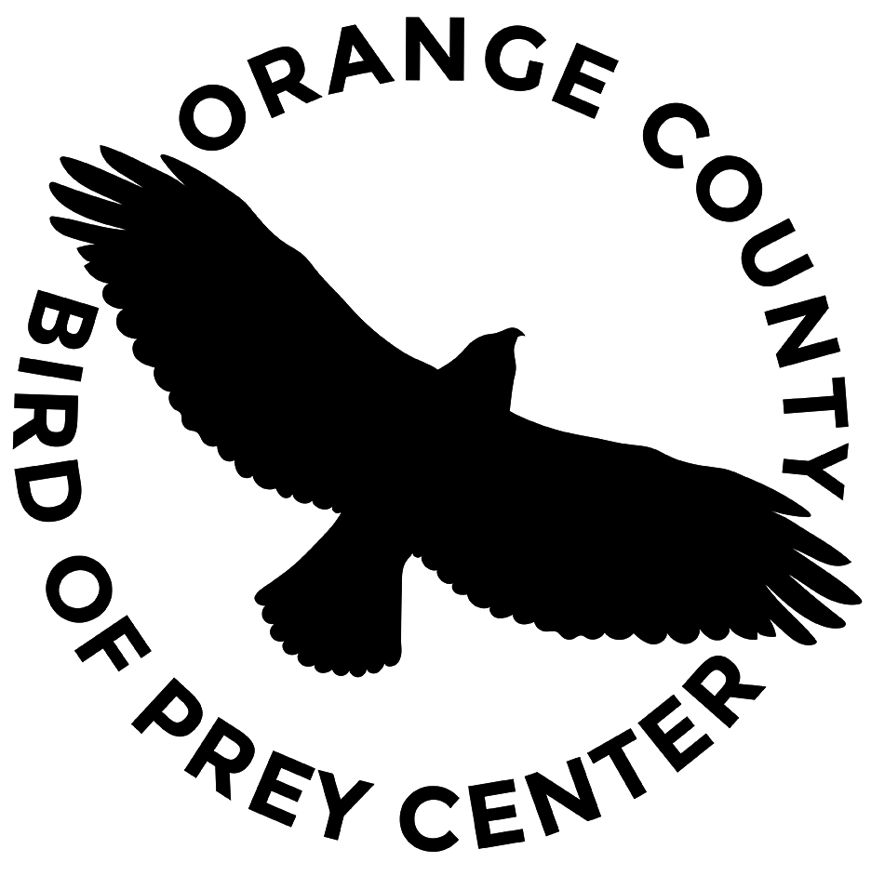

RAPTOR SPONSORSHIP PROGRAM
WWW.OCBPC.ORG

Your donation provides medical care and food to a rehabilitating bird to aid in returning the injured bird to the wild. A certificate will be mailed to you denoting the bird sponsored. We will contact you a few days in advance to either attend or release your sponsored bird.

NAME:___________________________________________________________DATE:___________

EMAIL: __________________________________________________________________________
(REQUIRED FOR RELEASE NOTIFICATION)
ADDRESS:_________________________________________________________________________

CITY:______________________________________ STATE:________ZIP______________________

PHONE: (______)______________________________ (REQUIRED FOR RELEASE NOTIFICATION)

HOW DID YOU HEAR ABOUT US?____________________________________________________

SPONSORSHIP LEVEL:
PERSONALLY RELEASE 1 SPONSORED BIRD ($200 - 1 release, up to 4 attendees) _________

ATTEND RELEASE ($50 individual, $100 family (up to 4 attendees) _________

TOTAL DONATION AMOUNT: $_________________

For youth group sponsorships, please contact donations@ocbpc.org

BIRD PREFERENCE SELECTION (In Order of Availability): Selection and sponsorship of an individual species does not guarantee actual release of requested species. Substitutions may occur based on availability at time of release.

RED SHOULDERED HAWK______ RED-TAILED HAWK______ COOPERS HAWK______

GREAT HORNED OWL______ BARN OWL______ KESTREL______ SCREECH OWL______

OTHER AVAILABLE______

OCBPC also has several “PERMANENT RESIDENT BIRDS” that are non-releasable and require continual support. These birds are foster parents for young birds and education ambassadors. If you would like to sponsor their continuing care instead of a releasable bird, please email donations@ocbpc.org.

Thank you for your support!
ORANGE COUNTY BIRD OF PREY CENTER
WWW.OCBPC.ORG
25422 Trabuco Rd. #105-541
Lake Forest, CA 92630-2797
(949) 837-0786
NON-PROFIT CORPORATION TAX ID NUMBER: 33-044-0942

